# **Created By Erum Sikander**

# **Hackathone-3 Day 2**

**My Introduction:**

My name is “Erum Sikander” I am from Hyderabad and I am a Student of the Sunday 2 to 5 pm Sir Ali Jawad Is my teacher and I am also a Senior Student…!

**Online Shopping Website:**

This project is a fully functional e-commerce website designed to provide a seamless shopping experience for users. The website integrates multiple features, such as product browsing, special offers, user authentication, and an easy-to-use checkout system. Below is a detailed description of the key sections and functionalities included in the website.

### **1. Homepage Layout and Navigation**

The homepage serves as the central hub for users to explore the store’s offerings. The navigation bar includes:

* A **search bar** for users to find products easily.
* A prominent banner showcasing seasonal promotions, such as "50% off on select items."
* Quick links to explore the best sellers and newly added items.

### **2. Product Categories**

The homepage highlights various product categories:

* **Bags for Women:** A selection of stylish handbags and purses tailored to women.
* **Winter Collection:** Clothing and accessories designed for the colder season.
* **Sandals for Women:** Trendy and comfortable footwear options.
* **Protect Your Eyes:** A collection of sunglasses to keep your eyes safe in style.

### **3. Step-by-Step Shopping Process**

The website simplifies the shopping journey into three clear steps:

1. **Find Your Favorite:** Users can browse a wide variety of high-quality products tailored to their preferences.
2. **Customize Your Order:** Customers can personalize or select product options as needed.
3. **Place Your Order:** With an optimized checkout flow, users can quickly finalize their purchases

### **4. Featured Products Section**

The homepage also features a section displaying the latest arrivals with product cards, such as:

* A **camera** priced at 2000.00.
* A high-quality **headphone** also priced at 2000.00.
* A sleek **laptop** available for the same price.

### **5. Exclusive Offers and Deals**

The "Special Offers" section is prominently displayed to attract customer attention. Deals include:

* **Happy Shopping:** Buy one, get one free on select items.
* **Home Appliances:** Discounts for purchasing multiple products.
* **Shoes Offer:** Another buy-one-get-one-free promotion.

### **6. User Authentication**

The website includes a login and sign-up modal that enables users to:

* Log in with an email and password.
* Sign in conveniently using Google authentication.

### **8. Visual Appeal and User Experience**

The website’s design is clean and modern, with:

* A dark-themed layout that makes images and text stand out.
* Clear typography and bold CTAs (Call to Actions) to guide users.
* High-quality images that enhance the overall aesthetic and user engagement.

### **9. Buy 1, Get 1 Free – Limited Time Only:**

Discover our exclusive collection, grab unbeatable deals, and shop now to save big….

### **10. Delivery Address Functionality:**

1. Full Name:
2. Phone Number:
3. Address:
4. City:
5. State:
6. Country:
7. Submit Button:

After filling out all required fields, users click the Submit button to save their delivery address and proceed to the next step...!

**For Example:**

* + **payment or order confirmation.**

**Checkout:**

* **Please confirm your order before proceeding.**

**Architecture Diagram Overview:**

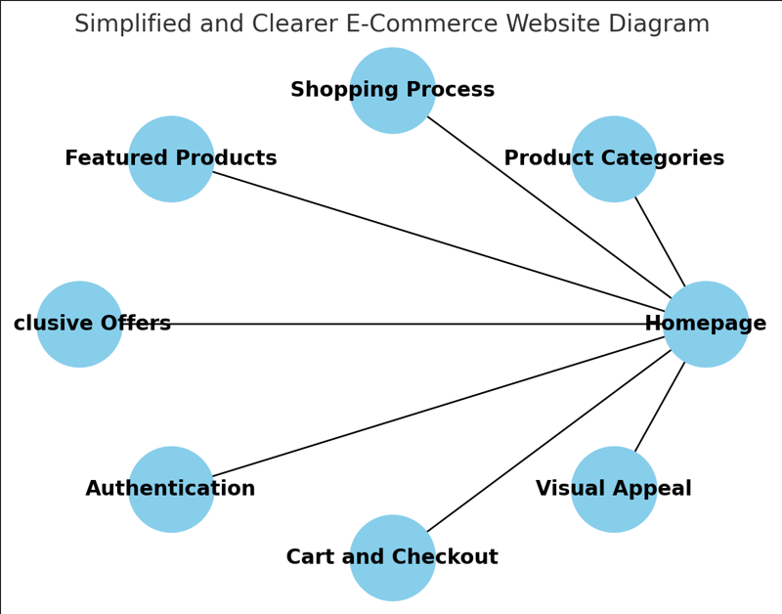

**API Endpoints Detail**

|  |  |  |  |  |
| --- | --- | --- | --- | --- |
| **Endpoint** | **Method** | **Description** | **Parameters** | **Response Example** |
| **/api/products** | **GET** | **Fetch all products** | **None** | **{id: 1, name: “Laptop”, price: 2000.00}** |
| **/api/products/:id** | **GET** | **Fetch a single product** | **id (Path)** | **{id: 1, name: “Laptop”, price: 2000.00}** |
| **/api/products** | **POST** | **Add a new product** | **name, price, category (Body)** | **{success: true, id: 5}** |

### **Conclusion**

This e-commerce website effectively combines functionality, aesthetics, and user-centric design. From product browsing to checkout, every feature is optimized to provide a hassle-free shopping experience. The integration of promotional offers, a responsive layout, and secure user authentication make this project a standout solution for online retail businesses…!

Thank you…!

“Sir Ameen Alam and my all teachers”

Erum Sikander

Your Obedient Student